**PROGRAM- 8**

**WRITE A CODE TO PERFORM BIT STUFFING AND BYTE STUFFING**

**BIT STUFFING:-**

#include<stdio.h>

#include<string.h>

int main()

{

int a[20],b[30],i,j,k,count,n;

printf("Enter frame size :");

scanf("%d",&n);

printf("Enter the frame in the form of 0 and 1 :");

for(i=0; i<n; i++)

scanf("%d",&a[i]);

i=0;

count=1;

j=0;

while(i<n)

{

if(a[i]==1)

{

b[j]=a[i];

for(k=i+1; a[k]==1 && k<n && count<5; k++)

{

j++;

b[j]=a[k];

count++;

if(count==5)

{

j++;

b[j]=0;

}

i=k;

}

}

else

{

b[j]=a[i];

}

i++;

j++;

}

printf("After Bit Stuffing :");

for(i=0; i<j; i++)

printf("%d",b[i]);

return 0;

}

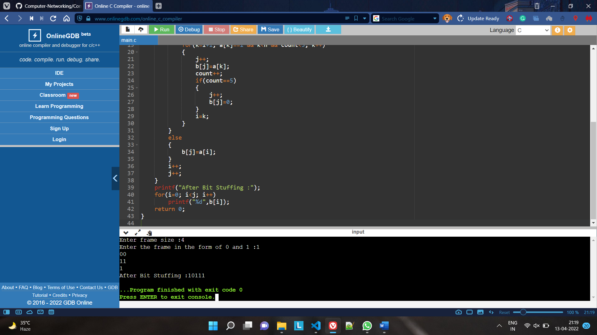

**BYTE STUFFING:-**

#include<stdio.h>

#include<string.h>

void main(){

char frame[50][50],str[50][50];

char flag[10];

strcpy(flag,"flag");

char esc[10];

strcpy(esc,"esc");

int i,j,k=0,n;

strcpy(frame[k++],"flag");

printf("Enter no.of String :\t");

scanf("%d",&n);

printf("Enter String \n");

for(i=0;i<=n;i++)

{

gets(str[i]);

}

printf("You entered :\n");

for(i=0;i<=n;i++)

{

puts(str[i]);

}

printf("\n");

for(i=1;i<=n;i++)

{

if(strcmp(str[i],flag)!=0 && strcmp(str[i],esc)!=0)

{

strcpy(frame[k++],str[i]);

}

else

{

strcpy(frame[k++],"esc");

strcpy(frame[k++],str[i]);

}

}

strcpy(frame[k++],"flag");

//frame[k++]='\0';

printf("------------------------------\n");

printf("Byte stuffing at sender side:\n\n");

printf("------------------------------\n");

for(i=0;i<k;i++)

{

printf("%s\t",frame[i]);

}

}

